# TUGAS RUTIN 1: BASIC WIDGET

Nama: Razha Jamsik Syah

Nim:5223351029

## Hasil UI Kode.

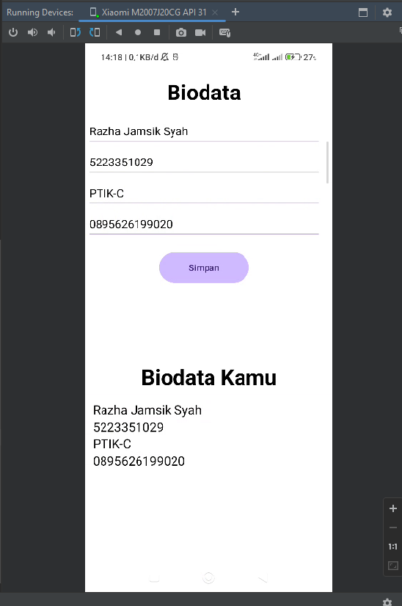

## UI Kode Pada MainActivity.

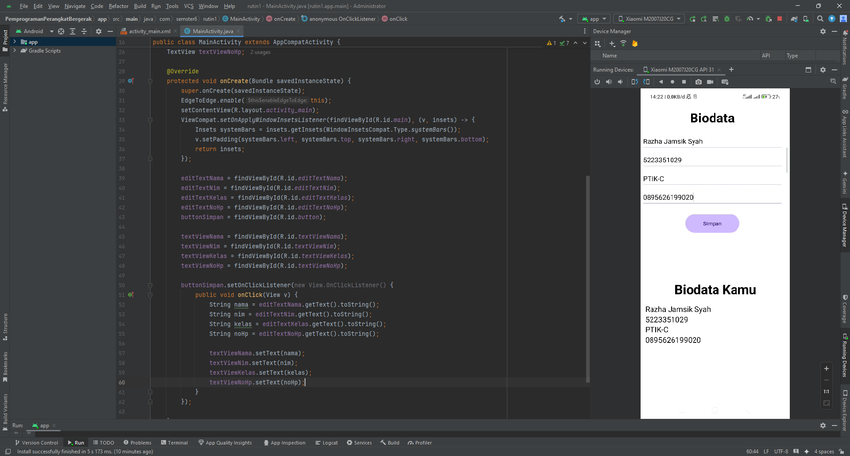

### 2.1. Kode.

|  |
| --- |
| package com.semster6.rutin1; import android.widget.EditText; import android.os.Bundle; import android.widget.Button; import android.view.View; import android.widget.TextView;  import androidx.activity.EdgeToEdge; import androidx.appcompat.app.AppCompatActivity; import androidx.core.graphics.Insets; import androidx.core.view.ViewCompat; import androidx.core.view.WindowInsetsCompat;    public class MainActivity extends AppCompatActivity {  EditText editTextNama;  EditText editTextNim;  EditText editTextKelas;  EditText editTextNoHp;  Button buttonSimpan;   TextView textViewNama;  TextView textViewNim;  TextView textViewKelas;  TextView textViewNoHp;   @Override  protected void onCreate(Bundle savedInstanceState) {  super.onCreate(savedInstanceState);  EdgeToEdge.*enable*(this);  setContentView(R.layout.*activity_main*);  ViewCompat.*setOnApplyWindowInsetsListener*(findViewById(R.id.*main*), (v, insets) -> {  Insets systemBars = insets.getInsets(WindowInsetsCompat.Type.*systemBars*());  v.setPadding(systemBars.left, systemBars.top, systemBars.right, systemBars.bottom);  return insets;  });   editTextNama = findViewById(R.id.*editTextNama*);  editTextNim = findViewById(R.id.*editTextNim*);  editTextKelas = findViewById(R.id.*editTextKelas*);  editTextNoHp = findViewById(R.id.*editTextNoHp*);  buttonSimpan = findViewById(R.id.*button*);   textViewNama = findViewById(R.id.*textViewNama*);  textViewNim = findViewById(R.id.*textViewNim*);  textViewKelas = findViewById(R.id.*textViewKelas*);  textViewNoHp = findViewById(R.id.*textViewNoHp*);   buttonSimpan.setOnClickListener(new View.OnClickListener() {  public void onClick(View v) {  String nama = editTextNama.getText().toString();  String nim = editTextNim.getText().toString();  String kelas = editTextKelas.getText().toString();  String noHp = editTextNoHp.getText().toString();   textViewNama.setText(nama);  textViewNim.setText(nim);  textViewKelas.setText(kelas);  textViewNoHp.setText(noHp);  }  });   } } |

## UI Kode Pada ActivityMain.

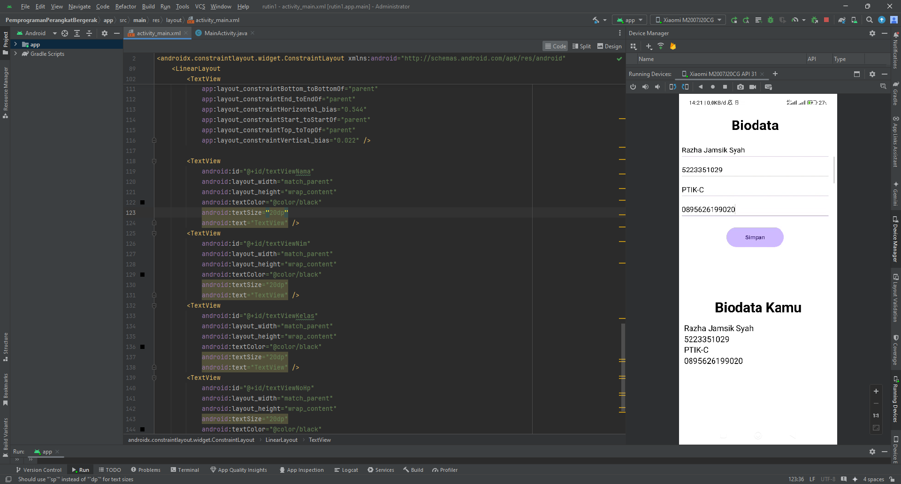

### 3.1. Kode.

|  |
| --- |
| <?xml version="1.0" encoding="utf-8"?> <androidx.constraintlayout.widget.ConstraintLayout xmlns:android="http://schemas.android.com/apk/res/android"  xmlns:app="http://schemas.android.com/apk/res-auto"  xmlns:tools="http://schemas.android.com/tools"  android:id="@+id/main"  android:layout_width="match_parent"  android:layout_height="match_parent"  android:background="@color/white"  tools:context=".MainActivity">   <LinearLayout  android:layout_width="408dp"  android:layout_height="373dp"  android:gravity="center"  android:orientation="vertical"  android:id="@+id/linearLayout1"  app:layout_constraintEnd_toEndOf="parent"  app:layout_constraintTop_toTopOf="parent">   <TextView  android:layout_width="wrap_content"  android:layout_height="wrap_content"  android:text="Biodata"  android:textColor="#000000"  android:textSize="34sp"  android:textStyle="bold"  android:layout_margin="16dp"  app:layout_constraintBottom_toBottomOf="parent"  app:layout_constraintEnd_toEndOf="parent"  app:layout_constraintHorizontal_bias="0.544"  app:layout_constraintStart_toStartOf="parent"  app:layout_constraintTop_toTopOf="parent"  app:layout_constraintVertical_bias="0.022" />   <EditText  android:id="@+id/editTextNama"  android:layout_width="373dp"  android:layout_height="49dp"  android:ems="10"  android:hint="Nama"  android:inputType="text"  android:textColor="@color/black"  tools:layout_editor_absoluteX="16dp"  tools:layout_editor_absoluteY="88dp" />   <EditText  android:id="@+id/editTextNim"  android:layout_width="373dp"  android:layout_height="49dp"  android:ems="10"  android:textColor="@color/black"  android:hint="Nim"  android:inputType="text"  tools:layout_editor_absoluteX="16dp"  tools:layout_editor_absoluteY="151dp" />   <EditText  android:id="@+id/editTextKelas"  android:layout_width="373dp"  android:textColor="@color/black"  android:layout_height="49dp"  android:ems="10"  android:hint="kelas"  android:inputType="text"  tools:layout_editor_absoluteX="16dp"  tools:layout_editor_absoluteY="219dp" />   <EditText  android:id="@+id/editTextNoHp"  android:layout_width="373dp"  android:layout_height="49dp"  android:textColor="@color/black"  android:ems="10"  android:hint="No Hp"  android:inputType="text"  tools:layout_editor_absoluteX="16dp"  tools:layout_editor_absoluteY="282dp" />   <Button  android:id="@+id/button"  android:layout_width="143dp"  android:layout_height="57dp"  android:text="Simpan"  android:layout_margin="16dp"  tools:layout_editor_absoluteX="140dp"  tools:layout_editor_absoluteY="355dp" />  </LinearLayout>   <LinearLayout  android:layout_width="409dp"  android:layout_height="356dp"  android:gravity="center"  android:orientation="vertical"  app:layout_constraintTop_toBottomOf="@id/linearLayout1"  app:layout_constraintStart_toStartOf="parent"  app:layout_constraintEnd_toEndOf="parent"  tools:layout_editor_absoluteX="1dp"  tools:layout_editor_absoluteY="374dp"  android:paddingHorizontal="20dp"  >   <TextView  android:layout_width="match_parent"  android:layout_height="wrap_content"  android:layout_margin="16dp"  android:text="Biodata Kamu"  android:textAlignment="center"  android:textColor="#000000"  android:textSize="34sp"  android:textStyle="bold"  app:layout_constraintBottom_toBottomOf="parent"  app:layout_constraintEnd_toEndOf="parent"  app:layout_constraintHorizontal_bias="0.544"  app:layout_constraintStart_toStartOf="parent"  app:layout_constraintTop_toTopOf="parent"  app:layout_constraintVertical_bias="0.022" />   <TextView  android:id="@+id/textViewNama"  android:layout_width="match_parent"  android:layout_height="wrap_content"  android:textColor="@color/black"  android:textSize="20dp"  android:text="TextView" />  <TextView  android:id="@+id/textViewNim"  android:layout_width="match_parent"  android:layout_height="wrap_content"  android:textColor="@color/black"  android:textSize="20dp"  android:text="TextView" />  <TextView  android:id="@+id/textViewKelas"  android:layout_width="match_parent"  android:layout_height="wrap_content"  android:textColor="@color/black"  android:textSize="20dp"  android:text="TextView" />  <TextView  android:id="@+id/textViewNoHp"  android:layout_width="match_parent"  android:layout_height="wrap_content"  android:textSize="20dp"  android:textColor="@color/black"  android:text="TextView" />  </LinearLayout>  </androidx.constraintlayout.widget.ConstraintLayout> |